**Higher Resolution Steering Angle**

To estimate the steering angle from the data provided, I used the relations:

$=\frac{l}{R} ----------(1)$

where is the average steering angle; $l$ is the longitudinal distance between the front wheel and back wheel; and $R$ is the radius of curvature of the car’s turn.

If we assume that the radius of the vehicle path changes slowly due to low vehicle speed or low yaw rate, then the rate of change of orientation of the vehicle must be equal to the angular velocity of the vehicle. Since the angular velocity of the vehicle is the yaw rate, we have

$R=v/$---------------------------------(2)

where v is the car’s velocity in the car’s reference frame and is the yaw rate.

Hence $=⁡(.\frac{l}{v})$-----------------------(3)

**System Identification Using State Space Model**

State space model

Equations for State Space model:

Jsӫs +Bsωs - Ksөs = τd + xr/rp ------------- (1)

Jmӫm +Bmωm - Kmөm = τm + xr*rg/rp ------------- (2)

Mrẍr +Brẋr + Krxr = τd + xr/rp ------------- (3)

Lі + Rı + Kωm = v ----------(4)

τm = kı ------- (5)

**Definition of variables:**

|  |  |
| --- | --- |
| Steering column inertia | Js |
| Steering column viscous damping | Bs |
| Steering column stiffness | Ks |
| Motor inertia | Jm |
| Motor viscous damping | Bm |
| Motor shaft stiffness | Km |
| Rack inertia | Mr |
| Rack viscous damping | Br |
| Rack stiffness | Kr |
| Motor inductance | L |
| Motor current constant | K |
| Terminal resistance of motor | R |
| Motor gear ratio | rg |
| Pinion radius | rp |
| Steering ratio | sr |
| Voltage across motor = | v |
| Driver Torque | τd (assumed to be zero) |
| Steering wheel angle | өs |
| Motor shaft angle | өm |
| Rack position | xr |
| Motor current | ı |
| Motor Torque | τm |

State variables = [өs ωs өm ωm ẋr  xr  ı]

Input vector = [τd v]

Output vector [өm]

|  |  |
| --- | --- |
| Parameter | Relation to steering angle |
| xr | = Lr* xr |
| өm | = sr* rg * өm |
| өs | = sr* өs |

The matrices of the state space model can be found in the “Steering_column” function in the “Project” file.

This state space description of the steering system dynamics was incorporated into a grey-box model. The Matlab script that executes this model is called “Input_Torque_statespace.m”

The simulated output of the model is plotted with the actual measurements in the figure below:



**System Identification Using nlarx**

I decided to devote my attention to nlarx for several reasons:

1. I could not properly model the nonlinearities in the steering system with the disturbance matrix in the grey-box estimation model.
2. The polynomial models I tried could not properly handle the nonlinearities in the system
3. I began to reason that if a parametric description of the some of the nonlinearities (notably aligning torque) can be incorporated as inputs to an estimator, I could increase the accuracy of my model.

The main advantage I saw in the nlarx model is that it lets you define custom regressors that enables one to incorporate prior knowledge of the system into the nonlinear estimators.

From research papers I studied, I was able to determine the profile of the aligning torque as a function of slip angle. This profile can be seen in the image below:

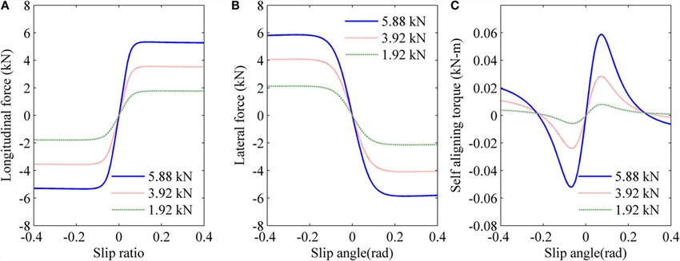

Because slip angle values for the tests drive were not provided, I decided to use the steering angle with some delay to account for difference in magnitude of steering angle in relation to slip angle.

(Note: Using yaw angles would have given a better approximation of slip angle. However, integrating yaw rates to get the yaw angle would incorporate significant drift errors to the yaw values.)

Using the figure above as a reference, I decided to model the aligning torque as a skewed sine function with an angular frequency of 0.1 rads (with respect to slip angle).

The skewed sine wave can be derived by adding harmonics of the basic sine function with appropriate coefficients. Since the maximum value of this function is 1; I decided to scale the skewed sine wave by multiplying it with the Voltage values.

Hence the basic harmonic in the regressor is:

Voltage(t-1).*sin(5*pi*steering angle(t-6))

This regressor gave the current best fit:

Voltage(t-1)+((1/50.001)*Voltage(t-1).*sin(5*pi*steering angle(t-6)))

The simulated response is compared with the measured data in the figure below:



**My confidence behind this approach:**

I tried varying certain values in the custom regressor to see the effects on the model.

First, I changed the angular frequency of the regressor. This is the custom regressor with a different angular frequency (changed from 5*pi to 1)

Voltage(t-1)+((1/50.000089)*Voltage(t-1).*sin(steering angle(t-6)))

The effect on the model is depicted below.



As the figure shows, the deviation of the system from the measured values is higher.

Next, I tried varying the coefficients of each harmonic in the regressor. This is the custom regressor with different coefficients for the harmonic (changed from 1/50.000089 to 1/50.001)

Voltage(t-1)+((1/50.001)*Voltage(t-1).*sin(5*pi*steering angle(t-6)))

The resulting model is compared to the measured data in the figure below:



As can be seen, the model is very sensitive to the coefficients of the harmonics in the custom regressor. A difference of 3.64392064e-7 in the coefficients of the base harmonic resulted in a 3.28% drop in the accuracy of the model.

So while adding more harmonics in the regressor has the potential to increase the accuracy of the model, computing the corresponding coefficients for these harmonics will be very difficult.

**Conclusion**

If a highly accurate, closed-form approximation of the aligning torque of a vehicle can be determined, the custom regressor regressor of this approximation can be used to increase the accuracy of an nlarx model.

**References**

Prasanth Babu Kandula. (2010). “Dynamics and Control of an Electric Power Assist Steering System”. Cleveland State University

Available from: [*https://engagedscholarship.csuohio.edu/cgi/viewcontent.cgi?referer=https://www.google.com/&httpsredir=1&article=1412&context=etdarchive*](https://engagedscholarship.csuohio.edu/cgi/viewcontent.cgi?referer=https://www.google.com/&httpsredir=1&article=1412&context=etdarchive)

[Rishi Ram Parajuli](https://www.researchgate.net/profile/Rishi_Ram_Parajuli) and Junji Kiyono. (July 2016). “[Circular Path and Linear Momentum Method for Seismic Response Analysis of Vehicles](https://www.researchgate.net/publication/305659235_Circular_Path_and_Linear_Momentum_Method_for_Seismic_Response_Analysis_of_Vehicles)”. Kyoto University.

Available at: *https://www.researchgate.net/publication/305659235_Circular_Path_and_Linear_Momentum_Method_for_Seismic_Response_Analysis_of_Vehicles*